Jefferson and the Declaration of Independence

In early May, 1776, Thomas Jefferson made a week-long journey from his home in Virginia to Philadelphia to be a delegate to the Second Continental Congress. At thirty-three years old, he was the youngest member of the Congress.
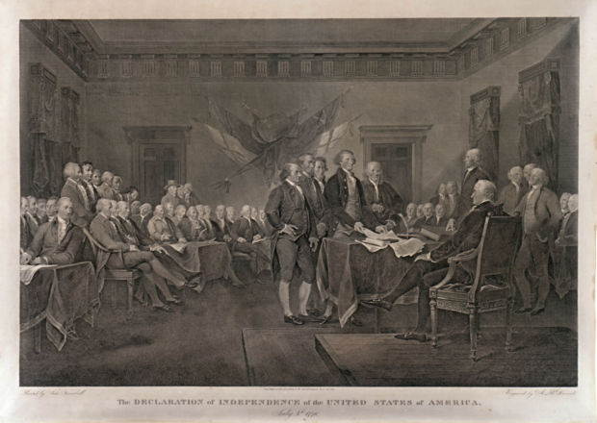
The Committee of Five
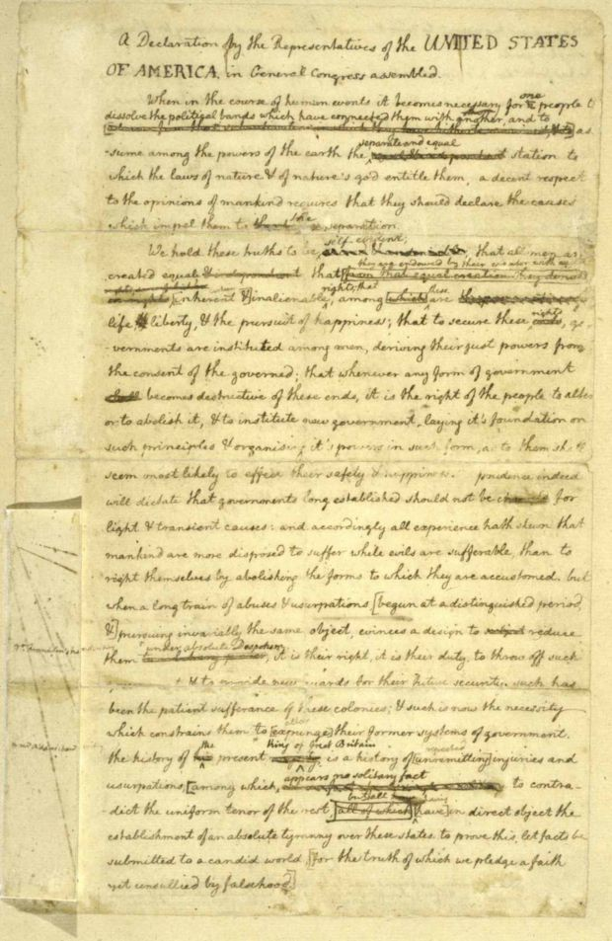
Congress appointed a committee of five delegates to draw up a statement explaining why the colonies wanted independence. They chose John Adams of Massachusetts, Roger Sherman of Connecticut, Benjamin Franklin of Pennsylvania, Robert Livingston of New York and Thomas Jefferson of Virginia.
Jefferson was not a fiery speaker. John Adams said of Jefferson, “During the whole time I sat with him in Congress, I never heard him utter three sentences together.” But he was known for his skill as a writer. The committee chose Jefferson to draft the declaration. Jefferson, however, wanted Adams to be the actual author. Adams reportedly replied, “You can write ten times better than I can.”

Jefferson's Rough Draft of the Declaration of Independence
Drafting the Declaration of Independence
The committee of five met several times to talk about ideas and organization. Thomas Jefferson then set out to draft a declaration. He worked for two and a half weeks in the parlor of his rented room. He’d rise before dawn and have tea and biscuits. Quill pen in hand, he’d sit down at his “plain, neat, convenient” writing desk that he had designed. He ripped up early drafts. Only a small piece of an early draft remains, showing he changed nearly one third of his words.
“I see my job as trying to bring together and harmonize a variety of different opinions,” Jefferson wrote. “We are putting before all of mankind words that are both simple and firm, a justification for the stand that we’re being forced to take.”
Influences on Jefferson’s Writing
Thomas Jefferson used no books or pamphlets to help him write the Declaration of Independence. But since his early days, he’d thought and read about government and the rights of mankind. He read British writer John Locke, who believed that people are born with natural rights. Governments should be for the benefit of everyone, not just the rulers. (These ideas were clear in Jefferson’s ideas for Virginia’s new state constitution.) Thomas Paine had also expressed a similar idea in his pamphlet titled Common Sense: “A government of our own is a natural right.”

Jefferson’s draft was also influenced by George Mason, a plantation owner in Virginia. Mason wrote a phrase similar to “pursuit of happiness” in his draft of “Virginia’s Declaration of Rights”, a phrase that appeared in Jefferson’s draft of the Decalration of Independence. Jefferson was probably influenced by Dr. William Small of Scotland as well. Small had taught Jefferson for four years at the College of William and Mary. Jefferson described his professor as a man with “an enlarged and liberal mind.” “I did not consider it a part of my charge to invent new ideas,” Thomas Jefferson later wrote about writing the Declaration, “but to place before mankind the common sense of the subject.”

All Men are Created Equal
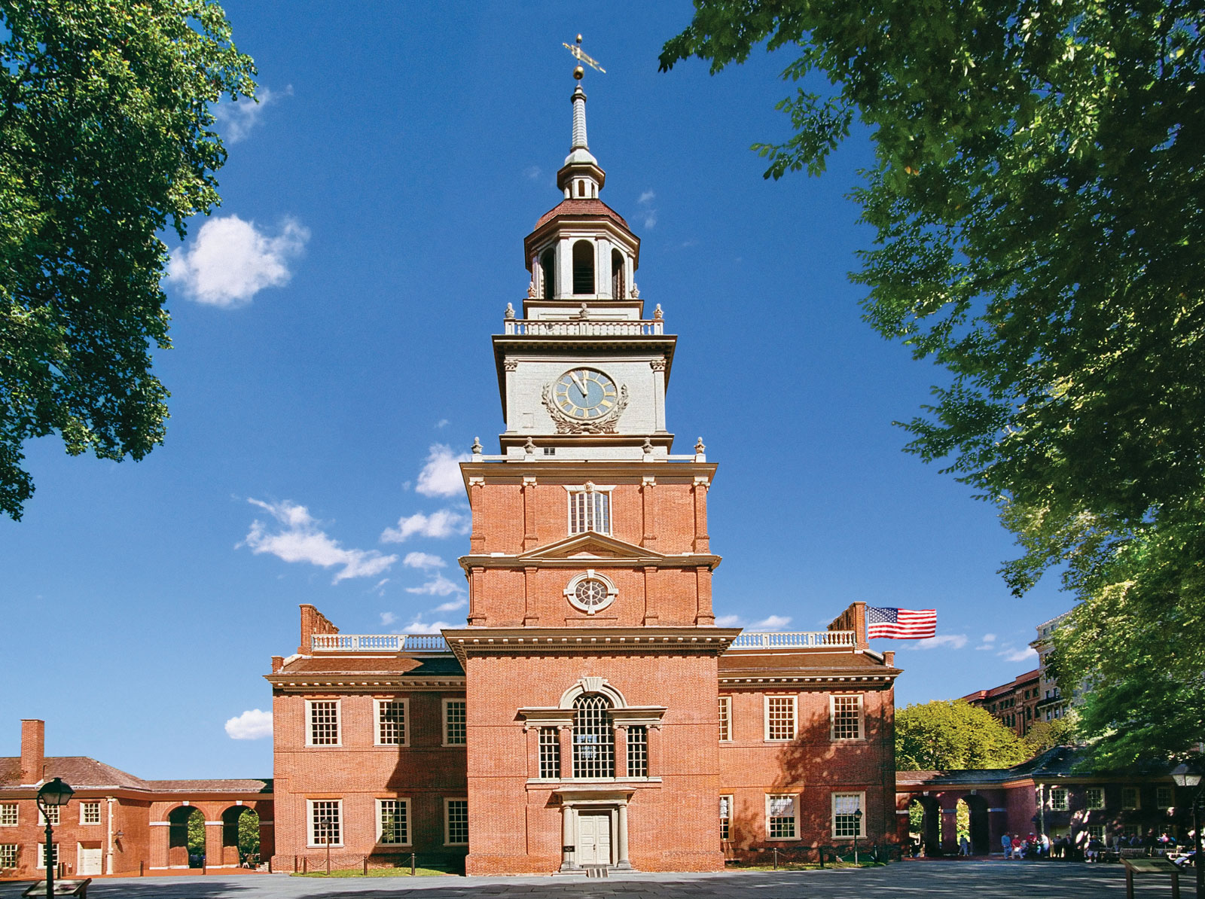
In the Declaration, Jefferson linked many of these ideas. In the first part of the Declaration (called the preamble) he wrote that all men have rights including “Life, Liberty and the pursuit of Happiness.” He wrote that the colonies were no longer bound to England. Governments should get their power from the people, not a king.
In another section, Jefferson listed the many ways that King George III had neglected his duties to the people. These included “imposing taxes on us without our Consent” and “cutting off our Trade with all parts of the world.”
Jefferson also drafted a section attacking the slave trade. He described slavery as “a cruel war against human nature itself, violating its most sacred rights of life and liberty.”
The final draft was shown to Franklin and Adams. They made a few small changes before giving it to Congress on June 28th, 1776. However, delegates from South Carolina and Georgia would not sign it because of the language against slavery. There were also delegates from New England who would not sign because their merchants had profited from the slave trade. Congress debated the issue, and all language about slavery was taken out.

Independence!
From late Tuesday July 2 through Thursday July 4th, Congress made changes in Jefferson’s draft of the Declaration. Jefferson’s text was cut by about a fourth. Congress also included the words of Lee’s Resolution “That these United Colonies are, and of Right ought to be Free and Independent States.” On July 4th delegates from twelve colonies voted for the written declaration.
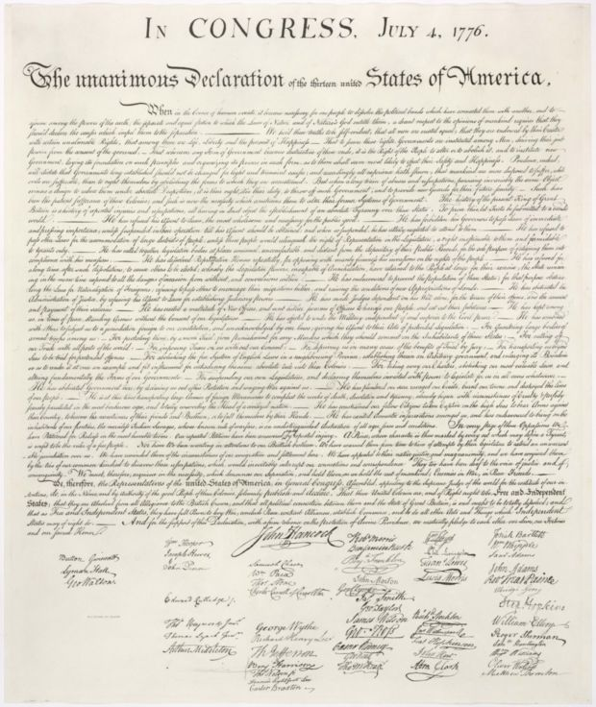
That day, in the late afternoon, Congress approved the written Declaration of Independence. John Hancock, president of Congress, signed it, making the document “legal and binding.” By doing this, the colonists viewed themselves as completely separate and independent of England. In the eyes of the British, this was considered treason, a crime punishable by death. Benjamin Franklin, before signing the document stated, “let us all hang together, or most assuredly, we will all hang separately”.
The first public reading of the Declaration of Independence was in Philadelphia on July 8th. The crowd cheered; church bells rang. By July 15th, all thirteen states had agreed to the resolutions in the new declaration. The Declaration was written on parchment made from animal skin. On August 2nd, it was signed by the members of Congress, including Thomas Jefferson.

Jefferson and the Declaration of Independence
Question 1: How did Jefferson’s character make him a good choice to draft the Declaration?

Jefferson and the Declaration of Independence

Question 2: How was Jefferson draft of the Declaration influenced by other’s?

Jefferson and the Declaration of Independence

Question 3: Why was writing the Declaration of Independence such a risk? Try thinking of two reasons!

Jefferson and the Declaration of Independence

Question 4: What were some of the main ideas that Jefferson included in his draft of the Declaration? Why do you suppose he included these?

